Experiment 5 Fourier Series Analysis of Periodic Signals
- To analyze Fourier series of continuous-time periodic signals and analyze their waveform Characteristics
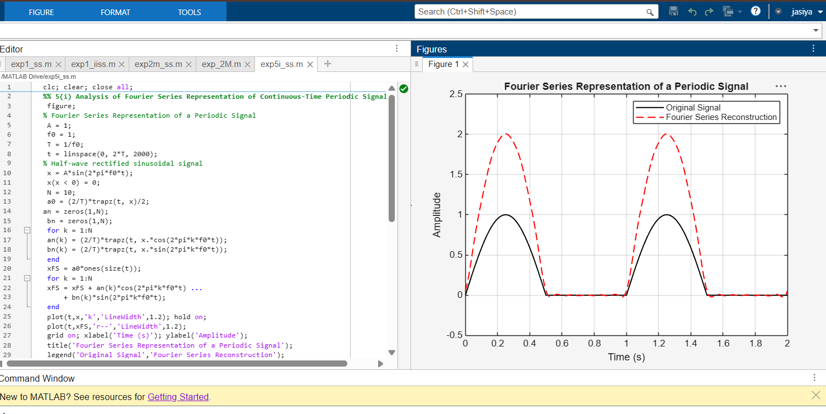
iv) To reconstruct periodic signals using Fourier series and verify the reconstructed waveform with the original signal
